**HELP IMPROVE** OCTAVIA’S SERVICES 

*Apply to join* ***Your Voice*** *- our resident services forum*

Would you like to work with other residents to check how Octavia is doing and feedback findings to the Octavia Board? We are looking for an additional enthusiastic and passionate leaseholder or shared owner to influence how services are delivered. We would really like to invite you to **put yourself forward as a candidate.**

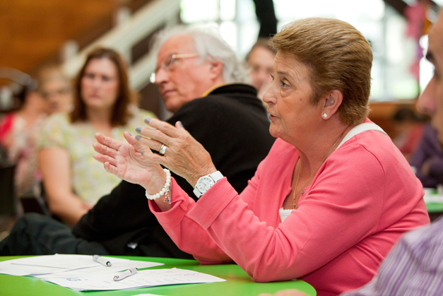

**What is Your Voice?**

Your Voice is our resident services forum. Your Voice examines a range of performance and resident feedback information. They commission several scrutiny projects a year to review the quality of Octavia’s services.

Your Voice makes recommendations to the Group Services Committee and Board, and has real influence.

**How much time do members need to give?**

Your Voice meet every two months and meetings are held from 6pm to 8pm. There may be the occasional additional meeting. Members receive an incentive of £25 per regular meeting and £20 for additional project meetings.

**What support will members receive?**

Members will be provided with training on the skills needed to fulfil their role and new members will be

matched with an experienced member who will act as their ‘buddy’ until they are settled into their role.

|  |  |  |
| --- | --- | --- |
| **What qualities and skills do I need?**  You must be an Octavia resident. We are looking for people who: | | |
| *Help Octavia improve* | *Work with others* | *Be a critical friend* |
| * Are passionate about making sure we provide a great service, and achieve our objectives. * Able to attend Your Voice meetings and take an active part in projects. * Able to weigh up issues and make fair judgements. | * Respect other’s views and keep to Your Voice’s terms of reference and Code of Conduct. * Work as part of a team and share skills and ideas with others. * Work in partnership with Octavia, staff and other residents. | * Have good listening skills. * Challenge performance or service issues in a constructive manner. * Utilise your experience as a resident, give your views, and help Octavia to provide an excellent service. |

*To apply please complete below:*

Title and name:

Address:

Tel: Email:

Please tell us below why you would be an ideal Your Voice member and about any issues you are interested in:

__________________________________________________________________________________________________________________________________________________________________________________________________________________

__________________________________________________________________________________________________________________________________________________________________________________________________________________

_________________________________________________________________________________________________________

Please return to Peter Walkinshaw (Resident Involvement Manager), Octavia Housing, Emily House, 202-208 Kensal Road, W10 5BN or to [peter.walkinshaw@octavia.org.uk](mailto:peter.walkinshaw@octavia.org.uk) - by Friday 3rd May 2019. Call Peter on 0208 354 5674 if you have any questions.